**OAK-SoM-IoT - Myriad X SoM Datasheet**

# Features

* Intel Movidius Myriad X VPU ma2485-C0
* 128MB QSPI NOR Flash
* 32Kb I2C EEPROM
* USB3.1, gen1 5gbps
* 1x 4-Lane MIPI CSI-2 D-PHY
* 2x 2-Lane MIPI CSI-2 D-PHY
* QSPI, SDIO, UART, I2C
* Boot Modes Supported: USB, NOR
* On-board power generation

# Applications

* Industrial automation
* Robotics and autonomy
* Security systems
* Remote intelligence

# Variants

OAK-SoM options are listed below based on VPU used on the SoM:

* Intel MA2485 with integrated 4Gbit DRAM
* Intel MA2085 with external DRAM:
  + 4Gbit
  + 8Gbit
  + 16Gbit

# Description

The Luxonis OAK-SoM-IoT is a system-on-module (SoM) designed for integration into a top-level system with a need for a low-power, 4 TOPS AI vision system. The OAK-SoM-IoT interfaces with the system through a single 10-gbps-rated 100-pin DF40C-100DP-0.4V(51) board-to-board mezzanine connector which carries all signal I/O as well as 5V input. The on-board SMPS system regulates the 5V input and provides all necessary digital and analog power. An auxiliary power port is offered to interface without connection to a baseboard.

Core digital electronics on the OAK-SoM-IoT include the Movidius Myriad X VPU (MA2485-C0), a 128MB QSPI NOR flash, and 32kb EEPROM.

USB 3.1 Gen1, QSPI, UART, I2C, and SDIO are all broken out from the SoM and routed through the mezzanine connector to the system. Additionally, the OAK-SoM-IoT SoM exposes two 2-lane MIPI CSI-2 D-PHY channels and one 4-lane MIPI CSI-2 D-PHY channel, allowing for multiple camera inputs.

Power-on Reset BOOT is selectable via an on-board DIP switch, and a 10-pin JTAG connector is also provided on-board to allow for debug without the need for a baseboard.

SoM power consumption is use-case dependent, but typical consumption is under 5W with thermal mitigation.

**Device Information**

|  |  |
| --- | --- |
| **PART NUMBER** | **SIZE (W x L x H)1** |
| OAK-SoM-IoT | 40mm x 30mm x 17.5mm |

1. Including components and heatsink

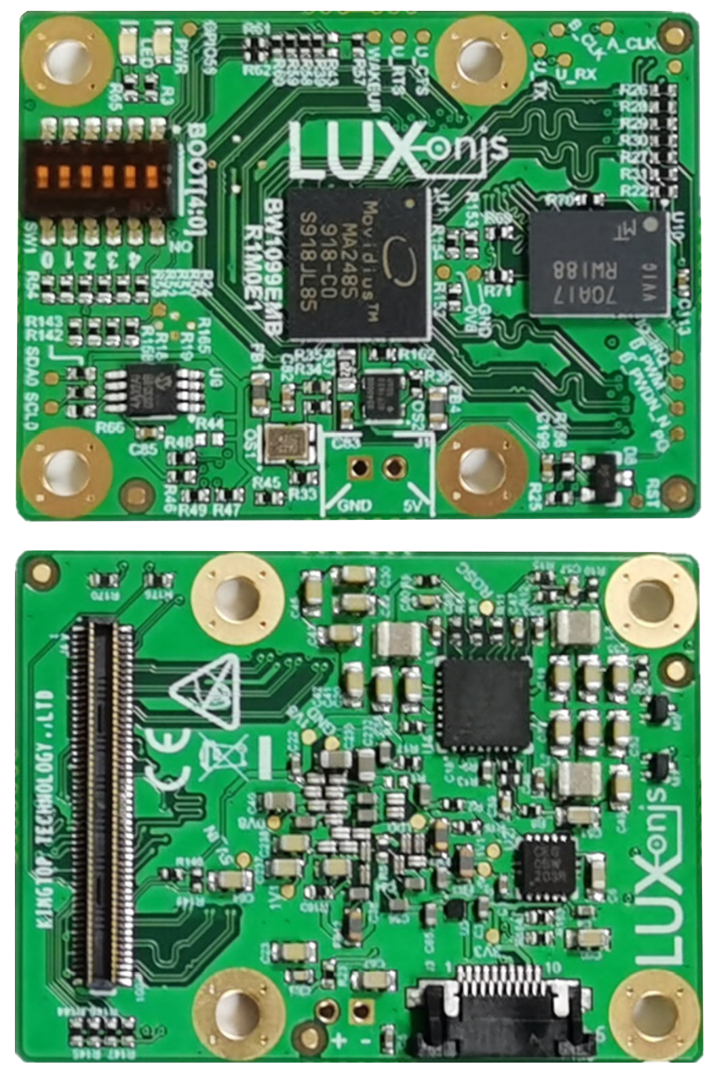

Figure 1 – Bottom and Top of OAK-SoM-IoT PCBA

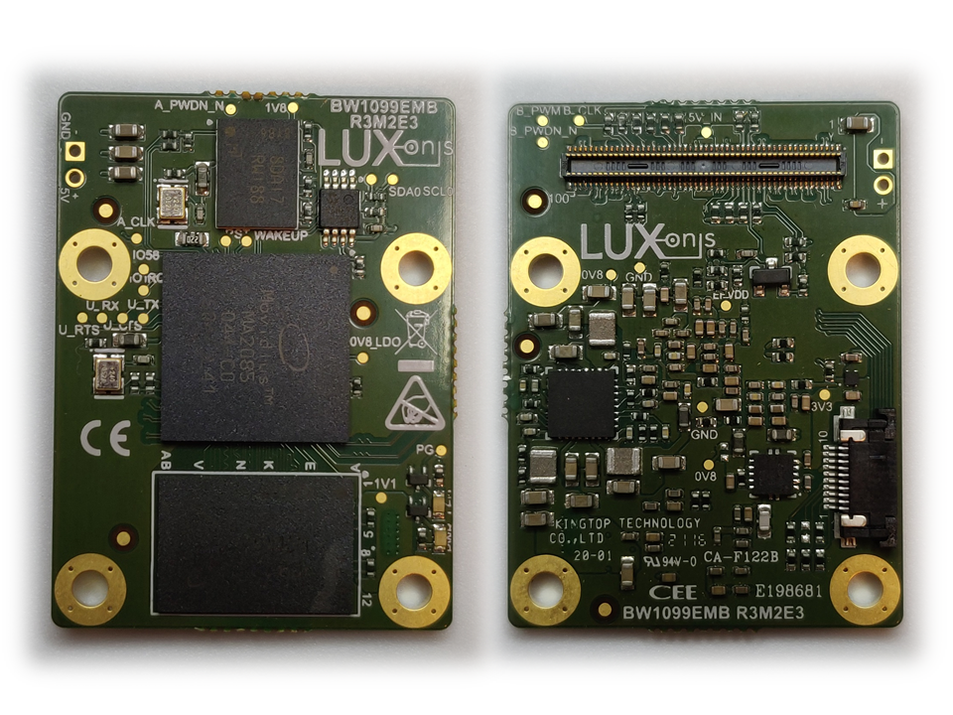

Figure – Top and Bottom of OAK-SoM PCBA (2085 with 8Gbit DRAM)

**Table of Contents**

1 Features 1

2 Applications 1

3 Variants 1

4 Description 1

5 Block Diagram 4

5 Electrical Characteristics 5

5.1 Absolute Maximum Ratings1 5

5.2 Recommended Operating Conditions 5

6 SoM Connector Interface 6

6.1 Pinout 6

6.2 I2C 7

**6.2.1** **RGB Camera I2C1 Address Usage** 7

**6.2.2** **Stereo Camera I2C2 Address Usage** 7

6.3 MIPI 7

6.4 PGOOD 8

6.5 WAKEUP 8

6.6 _RST 8

6.7 Camera Reference Clocks 8

6.8 Camera Reset Signals 8

6.9 1.8V Shared SPI0 (QSPI) 8

6.10 3.3V GPIO Bank 9

**6.10.1** **3.3V GPIO Bank - SDIO** 10

**6.10.2** **3.3V GPIO Bank – QSPI (SPI2)** 10

6.11 1.8V GPIO 10

7 BOOT Modes 12

8 Mechanical Information 13

8.1 OAK-SoM-IoT Dimensions 13

8.2 Recommended Mounting Configuration 14

8.3 OAK-SoM-IoT Mounting Holes 14

8.4 SoM Clearance 14

9 Thermal Information 14

10 Revision History 15

# Block Diagram

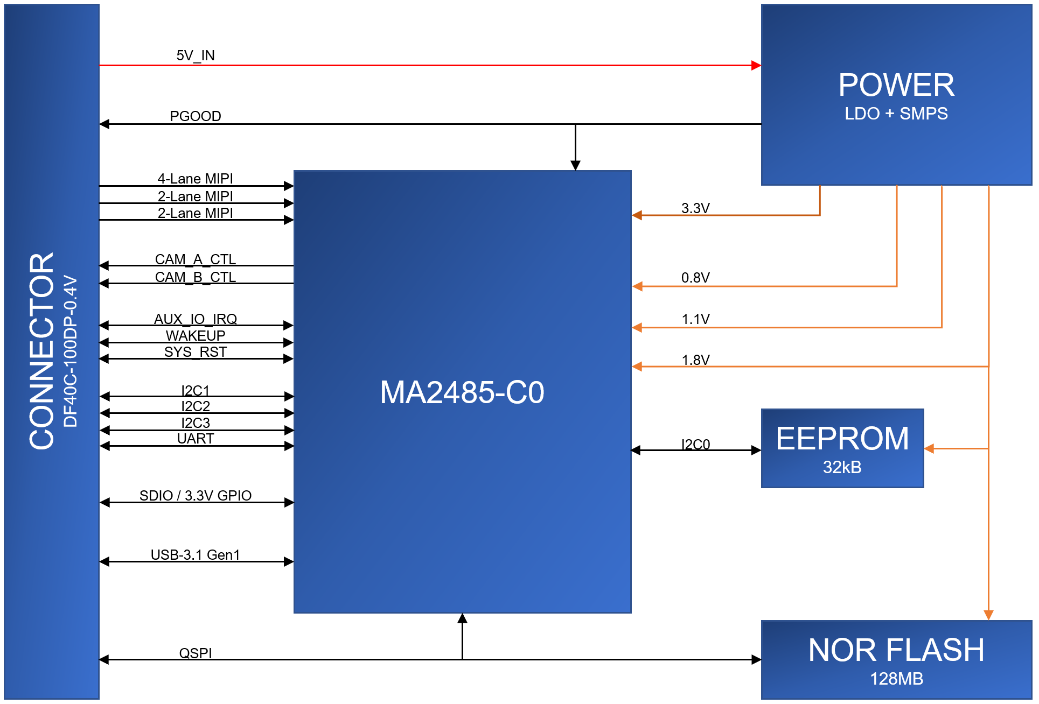

Figure 3 - Schematic Block Diagram

# 5 Electrical Characteristics

## 5.1 Absolute Maximum Ratings1

|  |  |  |  |  |
| --- | --- | --- | --- | --- |
| **SYMBOL** | **RATINGS** | **MIN** | **MAX** | **UNIT** |
| **V**IN | External input supply voltage range.2 | 3.6 | 5.5 | V |
| **V**I/O_1V8 | Input voltage SoM I/O for 1.8V logic | -0.3 | 2.0 | V |
| **V**I/O_3V3 | Input voltage SoM I/O for 3.3V logic | -0.3 | 3.6 | V |
| **I**I/O | IO output current drive strength | 2 | 12 | mA |
| **T**J | Junction temperature. |  | 105 | C |
| **T**STG | Storage temperature. | -30 | 150 | C |

## 5.2 Recommended Operating Conditions

|  |  |  |  |  |  |
| --- | --- | --- | --- | --- | --- |
| **SYMBOL** | **RATINGS** | **MIN** | **TYP** | **MAX** | **UNIT** |
| **V**IN | External input supply voltage range.2 | 4.5 | 5.0 | 5.25 | V |
| **V**I/O_1V8 | Input voltage SoM I/O for 1.8V logic | 0 |  | 1.8 | V |
| **V**I/O_3V3 | Input voltage SoM I/O for 3.3V logic | 0 |  | 3.3 | V |
| **P**Q | Quiescent power draw3 |  | 0.3 |  | W |
| **P**IDLE | Idle power draw4 |  | 0.7 |  | W |
| **P**INFR | Inference power draw5 |  | 2.48 |  | W |
| **T**A | Ambient operating temperature6 |  | 25 | 50 | °C |
| **T**J | Junction temperature.6 |  |  | 105 | °C |

1. Stresses beyond those listed under *Absolute Maximum Ratings* may cause permanent damage to the device. These are stress ratings only, which do not imply functional operation of the device at these or any other conditions beyond those indicated under *Recommended* *Operating Conditions*. Exposure to absolute-maximum-rated conditions for extended periods may affect device reliability.
2. Applies to 5V input pins only
3. With SoM in reset
4. Myriad X booted to base mode via USB
5. Mobilenet-SSDV2 detector, 30fps
6. With default Luxonis passive heatsink, running Mobilenet-SSDV2 30fps. Custom or active thermal solutions are recommended in ambient environments >50C, and/or for highly demanding inference operations >2.5W.

# 6 SoM Connector Interface

## 6.1 Pinout

The following contains the pinout of 100-pin Hirose DF40HC(3.0)-100DS-0.4V receptacle for the OAK-SoM-IoT. The schematic symbol, footprint, and full IO pinout table can be found at the Luxonis Github repository.

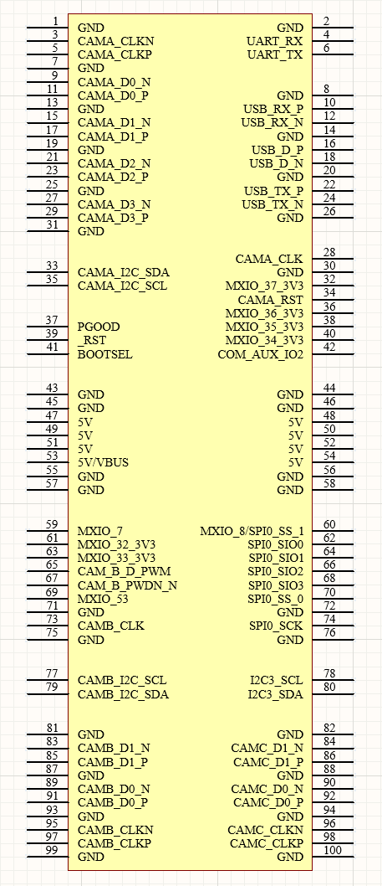

Figure 4 - Schematic Symbol for OAK-SoM-IoT Baseboard Receptacle Connector

## 6.2 I2C

The OAK-SoM-IoT SoM offers two dedicated I2C interfaces, I2C1 (CAMA_I2C), I2C2 (CAMB_I2C), both with 2.2Kohm pull-up resistors (SDA & SCL) to the on-SoM 1.8V rail. For custom baseboard designs, each of the two I2C interfaces are available and are not in use for anything else on the SoM. On most Luxonis baseboards, such as the BW1098 family, the I2C1 interface is used for communication with the RGB color camera, the I2C2 interface is used to communicate with the pair of stereo cameras, and the I2C3 is typically unused but accessible through test points or connector pads.

### **6.2.1 RGB Camera I2C1 Address Usage**

The IMX378 RGB camera on most Luxonis baseboards uses some specific addresses as seen in Figure 5. Use of the I2C1 interface on other components is possible, but with consideration of the existing usage of the RGB camera.

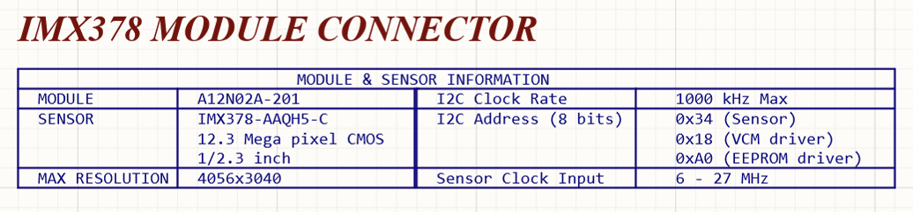

Figure 5 - Baseboard I2C1 RGB Camera Module Usage

### **6.2.2 Stereo Camera I2C2 Address Usage**

The pair of OV9282 sensors comprising the stereo pair some Luxonis baseboards uses specific addresses as seen in Figure 6. Use of the I2C2 interface on other components is possible, but with consideration of the existing usage of the stereo camera.

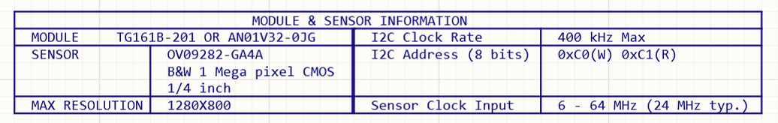

Figure 6 - Baseboard I2C2 Stereo Camera Module Usage

## 6.3 MIPI

Three MIPI CSI-2 DPHYv1.2 interfaces are available as input to the SoM. One is a 4-lane interface, and the other two interfaces are 2-lane each, all allowing a maximum of 2.1Gbps per lane.

For each of the three camera interfaces, the inter-pair delay of that interface is matched to the clock pair within +/-1ps, and all pairs are routed with 100ohm differential impedance.

## 6.4 PGOOD

PGOOD is a 1.8V open-drain output from the SoM PMIC and is pulled high when the PMIC evaluates power is good. PGOOD has a 10Kohm pull-up resistor to the on-SoM 1.8V rail.

This pin should be left floating if unused or tied to a high-impedance input to sense PGOOD. Do not pull or tie PGOOD to GND.

## 6.5 WAKEUP

WAKEUP is a 1.8V input to the SoM which is pulled to GND through a 10Kohm resistor. If driven high and sensed during the rising edge of _RST power-on-reset, the on-chip e-fuse is used for boot selection. At present, this functionality is not used on any Luxonis SoM.

The WAKEUP pin was originally intended for waking the SoM from deep sleep mode, but this functionality is not supported on Luxonis SoMs. However, any MXIO can be used to trigger an interrupt and wake the SoM. The WAKEUP should be left floating.

## 6.6 _RST

_RST is the active-low Myriad X reset input. _RST has a 1.8V 10Kohm pull-up resistor on the SoM, and can be driven low from the baseboard to reset the Myriad X.

## 6.7 Camera Reference Clocks

Two pins are used to provide a 24MHz reference clock to the image sensor ICs on the baseboard. These signals are on the CAMA_CLK and CAMB_CLK pins of the SoM interface connector. Each signal has a 121Kohm, pull down on the SoM. It is possible to create additional reference clocks for additional cameras by reconfiguring an MXIO pin.

## 6.8 Camera Reset Signals

Three pins are used for individually resetting or powering down the RGB and stereo pair cameras. These signals are CAMA_RST, CAM_B_D_PWM, and CAM_B_PWDN_N, for the RGB, LEFT, and RIGHT cameras respectively. Each of these signals is 1.8V and are active-low. No pull-up or pull-down resistors are on these signals on the SoM.

## 6.9 1.8V Shared SPI0 (QSPI)

The signals with prefix “SPI0” are part of a QSPI bus which is shared with the optional on-SoM NOR flash. Note the signal configuration details in Table 1 (refer to the [OAK-SoM-IoT IO TABLE](https://github.com/luxonis/depthai-hardware/blob/master/SoMs/OAK-SoM-IoT/OAK-SoM-IoT_IO_TABLE.xlsx) for more details). All signals related to SPI0 are delay-matched on the SoM to +/-100ps to the connector interface.

|  |  |  |  |  |  |  |
| --- | --- | --- | --- | --- | --- | --- |
| **Pin #** | **Pin name / Primary Function** | **SoM GPIO** | **Alt. 1** | **PU/PD on SoM** | **Pin Type** | **Description** |
| 60 | MXIO_8/SPI0_CS_1 | MXIO_8 | SPI0_CS_1 |  | 1.8V GPIO | GPIO, or can be configured as second CS for SPI0, MX in Controller or Peripheral mode. / +/-100ps inter-SPI0 |
| 70 | SPI0_CS_0 | MXIO_5 |  | PU: 1kR/1.8V | 1.8V GPIO | Hardwired to OAK-SoM on-board NOR S# / +/-100ps inter-SPI0 |
| 74 | SPI0_SCK | MXIO_4 |  |  | 1.8V GPIO | Hardwired to OAK-SoM on-board NOR C / +/-100ps inter-SPI0 |
| 62 | SPI0_SIO0 | MXIO_0 |  |  | 1.8V GPIO | Hardwired to OAK-SoM on-board NOR DQ0 / +/-100ps inter-SPI0 |
| 64 | SPI0_SIO1 | MXIO_1 |  |  | 1.8V GPIO | Hardwired to OAK-SoM on-board NOR DQ1 / +/-100ps inter-SPI0 |
| 66 | SPI0_SIO2 | MXIO_2 |  | PU: 1kR/1.8V | 1.8V GPIO | Hardwired to OAK-SoM on-board NOR W#/DQ2 / +/-100ps inter-SPI0 |
| 68 | SPI0_SIO3 | MXIO_3 |  | PU: 1kR/1.8V | 1.8V GPIO | Hardwired to OAK-SoM on-board NOR DQ3/HOLD# / +/-100ps inter-SPI0 |

Table - SPI0 Pin Configuration

With the NOR flash unpopulated the SPI0 bus can be used by the Myriad X in either controller or peripheral mode. With the Myriad X in controller mode, SPI0_CS_0 and SPI0_CS_1 can be used as chip selects for any baseboard peripherals, and additional baseboard chip selects can be configured by using GPIOs, if required. With the Myriad X in peripheral mode, either the SPI0_CS_0 or SPI0_CS_1 can be used by the baseboard controller to select the Myriad X as a peripheral. Unlike for controller mode, in peripheral mode, GPIOs cannot be configured as chip selects for the Myriad X, only SPI0_CS_0 and SPI0_CS_1 can be used for this purpose.

With the NOR flash populated, the SPI0 bus can still be used by the Myriad X in either controller or peripheral mode, but the NOR flash now occupies the SPI0_CS_0 location so some care must be taken to avoid contention. With the NOR flash populated, and the Myriad X is in controller mode, the SPI0_CS_0 selects the NOR flash. SPI0_CS_1 (or other reconfigured MXIO) can be used as a second chip select for baseboard peripherals. When in peripheral mode SPI0_CS_1 should be used as the chip select for the peripheral Myriad X to avoid contention when communicating with NOR flash using SPI0_CS_0.

Note that when an external controller is accessing the NOR flash on the SoM, the Myriad X must not be allowed to access at the same time. Asserting _RST for the Myriad X is an option to prevent this contention.

## 6.10 3.3V GPIO Bank

The SoM offers six GPIO which are 3.3V signaling for easy interface to common peripherals and devices with 3.3V signaling. These GPIO offer several configurations including SDIO, QSPI, UART, PWM, and I2C, along with general purpose IO and are listed in Table 2 (refer to the [OAK-SoM-IoT IO TABLE](https://github.com/luxonis/depthai-hardware/blob/master/SoMs/OAK-SoM-IoT/OAK-SoM-IoT_IO_TABLE.xlsx) for more details).

|  |  |  |  |  |  |  |  |  |  |
| --- | --- | --- | --- | --- | --- | --- | --- | --- | --- |
| **Pin #** | **Pin name / Primary Function** | **SoM GPIO** | **Alt. 1** | **Alt. 2** | **Alt. 3** | **Alt. 4** | **PU/PD on SoM** | **Pin Type** | **Description** |
| 40 | MXIO_34_3V3 | MXIO_34 | sd_hst0_dat_0 | spi2_dio_2 | pwm_0 | I2C3_SDA | PU: 40.2kR/1.8V | 3.3V GPIO | 3.3V GPIO. Note PU/PD resistors that are configured for SDIO, but also compatible with SPI. / +/-100ps inter-SD_HST |
| 61 | MXIO_32_3V3 | MXIO_32 | sd_hst0_clk | spi2_dio_0_mosi |  |  | PU: 40.2kR/1.8V | 3.3V GPIO | 3.3V GPIO. Note PU/PD resistors that are configured for SDIO, but also compatible with SPI. / +/-100ps inter-SD_HST |
| 63 | MXIO_33_3V3 | MXIO_33 | sd_hst0_cmd | spi2_dio_1_miso |  | I2C3_SCL | PU: 40.2kR/1.8V | 3.3V GPIO | 3.3V GPIO. Note PU/PD resistors that are configured for SDIO, but also compatible with SPI. / +/-100ps inter-SD_HST |
| 32 | MXIO_37_3V3 | MXIO_37 | sd_hst0_dat_3 | spi2_cs_0 | pwm_3 | UART3_TX | PD: 300kR/GND | 3.3V GPIO | 3.3V GPIO. Note PU/PD resistors that are configured for SDIO, but also compatible with SPI. / +/-100ps inter-SD_HST |
| 36 | MXIO_36_3V3 | MXIO_36 | sd_hst0_dat_2 | spi2_sclk |  |  | PU: 40.2kR/1.8V | 3.3V GPIO | 3.3V GPIO. Note PU/PD resistors that are configured for SDIO, but also compatible with SPI. / +/-100ps inter-SD_HST |
| 38 | MXIO_35_3V3 | MXIO_35 | sd_hst0_dat_1 | spi2_dio_3 |  | UART3_RX | PU: 40.2kR/1.8V | 3.3V GPIO | 3.3V GPIO. Note PU/PD resistors that are configured for SDIO, but also compatible with SPI. / +/-100ps inter-SD_HST |

Table 2 - 3.3V GPIO Pin Configuration

### **6.10.1 3.3V GPIO Bank - SDIO**

The 3.3V GPIO bank is nominally configured for use with SDIO, as appropriate pull-up and pull-down resistors exist on the SoM. CLK, CMD, and DAT[0:3] are available for use. Optional signals such as card detect can be implemented using the 1.8V GPIO.

### **6.10.2 3.3V GPIO Bank – QSPI (SPI2)**

The 3.3V GPIO bank can be configured as a QSPI bus. The weak pull-up and pull-down resistors on the signal lines (for use as SDIO) are over driven when used as a QSPI interface, though maximum data rates are not guaranteed. Like the SPI0 bank, the 3.3V QSPI interface can operate as a controller or peripheral using the SPI2_CS_0 signal. Additional chip selects can be sent to baseboard peripherals with other 1.8V GPIO, though the need to level shift from 1.8V to 3.3V may be necessary.

## 6.11 1.8V GPIO

The default IO voltage for all GPIO is 1.8V, with the exceptions of the 3.3V GPIO listed in Table 2 (refer to the [OAK-SoM-IoT IO TABLE](https://github.com/luxonis/depthai-hardware/blob/master/SoMs/OAK-SoM-IoT/OAK-SoM-IoT_IO_TABLE.xlsx) for more details). In addition to muxed functionality, each MXIO is fully user-programmable with support or four output drive strengths (2mA, 4mA, 8mA, 12mA), selectable output slew-rate (slow/fast), open-drain output mode, LVCMOS/LVTTL compatible input modes with selectable hysteresis, programmable pull-up/pull-down input options, power-on-start capability, and no requirements for power sequencing. Additionally, 100MHz frequency can be achieved with less than 15pF external load, or up to 125MHz with less than 10pF external load.

|  |  |  |  |  |  |  |  |
| --- | --- | --- | --- | --- | --- | --- | --- |
| **Pin #** | **Pin name / Primary Function** | **SoM GPIO** | **Alt. 1** | **Alt. 2** | **PU/PD on SoM** | **Pin Type** | **Description** |
| 4 | MXIO_46 | MXIO_46 | UART_RX | pwm3 |  | 1.8V GPIO | Typically labeled as UART_RX on Luxonis baseboards. |
| 28 | CAMA_CLK | MXIO_44 |  |  | PD: 121kR/GND | 1.8V GPIO | 24MHz reference clock for Camera A PLL |
| 33 | CAMA_I2C_SDA | MXIO_21 | pwm5 |  | PU: 2.2kR/1.8V | 1.8V GPIO | I2C data for Camera A |
| 34 | CAMA_RST | MXIO_31 |  |  |  | 1.8V GPIO | Camera A reset/power down. |
| 35 | CAMA_I2C_SCL | MXIO_20 |  |  | PU: 2.2kR/1.8V | 1.8V GPIO | I2C clock for Camera A |
| 42 | COM_AUX_IO2 | MXIO_41 |  |  |  | 1.8V GPIO | Auxiliary GPIO for cameras sync/trigger. Reserved for interrupt FSIN (Frame sync input) for the cameras used. |
| 59 | MXIO_7 | MXIO_7 |  |  | PU: 40.2kR/1.8V | 1.8V GPIO | Configured for SDIO card detect, or as regular GPIO. Note 1.8V, 40.2k PU. / +/-100ps inter-SD_HST |
| 60 | MXIO_8/SPI0_CS_1 | MXIO_8 | SPI0_CS_1 |  |  | 1.8V GPIO | GPIO, or can be configured as second CS for SPI0, MX in Controller or Peripheral mode. / +/-100ps inter-SPI0 |
| 62 | SPI0_SIO0 | MXIO_0 |  |  |  | 1.8V GPIO | Hardwired to OAK-SoM on-board NOR DQ0 / +/-100ps inter-SPI0 |
| 64 | SPI0_SIO1 | MXIO_1 |  |  |  | 1.8V GPIO | Hardwired to OAK-SoM on-board NOR DQ1 / +/-100ps inter-SPI0 |
| 65 | CAM_B_D_PWM | MXIO_57 |  |  |  | 1.8V GPIO | Camera C reset/power down. |
| 66 | SPI0_SIO2 | MXIO_2 |  |  | PU: 1kR/1.8V | 1.8V GPIO | Hardwired to OAK-SoM on-board NOR W#/DQ2 / +/-100ps inter-SPI0 |
| 67 | CAM_B_PWDN_N | MXIO_54 |  |  |  | 1.8V GPIO | Camera B reset/power down. |
| 68 | SPI0_SIO3 | MXIO_3 |  |  | PU: 1kR/1.8V | 1.8V GPIO | Hardwired to OAK-SoM on-board NOR DQ3/HOLD# / +/-100ps inter-SPI0 |
| 70 | SPI0_CS_0 | MXIO_5 |  |  | PU: 1kR/1.8V | 1.8V GPIO | Hardwired to OAK-SoM on-board NOR S# / +/-100ps inter-SPI0 |
| 73 | CAMB_CLK | MXIO_47 |  |  | PD: 121kR/GND | 1.8V GPIO | 24MHz reference clock for Camera B PLL |
| 74 | SPI0_SCK | MXIO_4 |  |  |  | 1.8V GPIO | Hardwired to OAK-SoM on-board NOR C / +/-100ps inter-SPI0 |
| 77 | CAMB_I2C_SCL | MXIO_22 |  |  | PU: 2.2kR/1.8V | 1.8V GPIO | Camera B I2C SDA. Can be used as GPIO. |
| 79 | CAMB_I2C_SDA | MXIO_23 |  |  | PU: 2.2kR/1.8V | 1.8V GPIO | Camera B I2C SCL. Can be used as GPIO. |
| 6 | MXIO_45 | MXIO_45 | UART_TX | pwm2 |  | 1.8V GPIO | Typically labeled as UART_TX on Luxonis baseboards. |
| 69 | MXIO_53 | MXIO_53 |  |  |  | 1.8V GPIO |  |
| 78 | MXIO_24 | MXIO_24 | I2C3_SCL |  | PU: 2.2kR/1.8V | 1.8V GPIO | Camera C I2C SCL (if applicable). Can be used as GPIO |
| 80 | MXIO_25 | MXIO_25 | I2C3_SDA |  | PU: 2.2kR/1.8V | 1.8V GPIO | Camera C I2C SDA (if applicable). Can be used as GPIO |

Table - 1.8V GPIO Pin Configuration

## 6.12 USB3.1 Gen2

USB3.1 is exposed it can operate as a device. Maximum of 10Gbps serial data rate can be achieved.

|  |  |  |  |  |  |  |
| --- | --- | --- | --- | --- | --- | --- |
| **Pin/**  **Conn. #** | **Pin name / Primary Function** | **SoM GPIO** | **Alt. 1** | **PU/PD on SoM** | **Pin Type** | **Description** |
| 24 | USB_TX_N | USB_TX_N |  |  | USB3 | USB 3.0 SSTX (-) / No AC caps on SoM / 0.5ps intra-pair tuning / 90ohm +/-10% |
| 22 | USB_TX_P | USB_TX_P |  |  | USB3 | USB 3.0 SSTX (+) / No AC caps on SoM / 0.5ps intra-pair tuning / 90ohm +/-10% |
| 10 | USB_RX_P | USB_RX_P |  |  | USB3 | USB 3.0 SSRX (+) / 0.5ps intra-pair tuning / 90ohm +/-10% |
| 12 | USB_RX_N | USB_RX_N |  |  | USB3 | USB 3.0 SSRX (-) / 0.5ps intra-pair tuning / 90ohm +/-10% |
| 18 | USB_D_N | USB_D_N |  |  | USB2 | USB 2.0 (-) / 2ps intra-pair tuning / 90ohm +/-10% |
| 16 | USB_D_P | USB_D_P |  |  | USB2 | USB 2.0 (+) / 2ps intra-pair tuning / 90ohm +/-10% |
| 53 | 5V/VBUS | 5V/VBUS |  |  | PWR | USB UFP VBUS sense input for VBUS detect. Can be tied to 5V to enable Myriad X USB for embedded applications. |

Table 4 - USB Pin Configuration

# 7 BOOT Modes

The DIP switch on the OAK-SoM-IoT offers the end user the option to easily configure the boot mode by setting the BOOT[4:0] bits. These bits are sampled on the rising edge of _RST during power-on-reset, and allow for boot from USB and SPI NOR flash. The BOOT[4:0] bits are labeled on the PCB silk screen.

To configure the NOR flash boot mode, set the bits to 0x8 [0b01000]. In this configuration, the Myriad X acts as an SPI controller on SPI0 to boot from the NOR flash with SPI settings: 24-bit addr, Quad I/O, and at a rate of 50MHz. It is also possible to boot with the Myriad X configured as an SPI peripheral, but this feature is not yet fully supported.

To configure the USB boot, set bits to 0x16 [0b10110]. In this configuration, the Myriad X will boot using the USB 2 interface.

# 8 Mechanical Information

The following information is [the most](http://www.ti.com/corp/docs/legal/termsofuse.shtml) [current](http://www.ti.com/corp/docs/legal/termsofuse.shtml) data available for the designated device. This data is subject to change without notice and without revision of this document.

## 8.1 OAK-SoM-IoT Dimensions

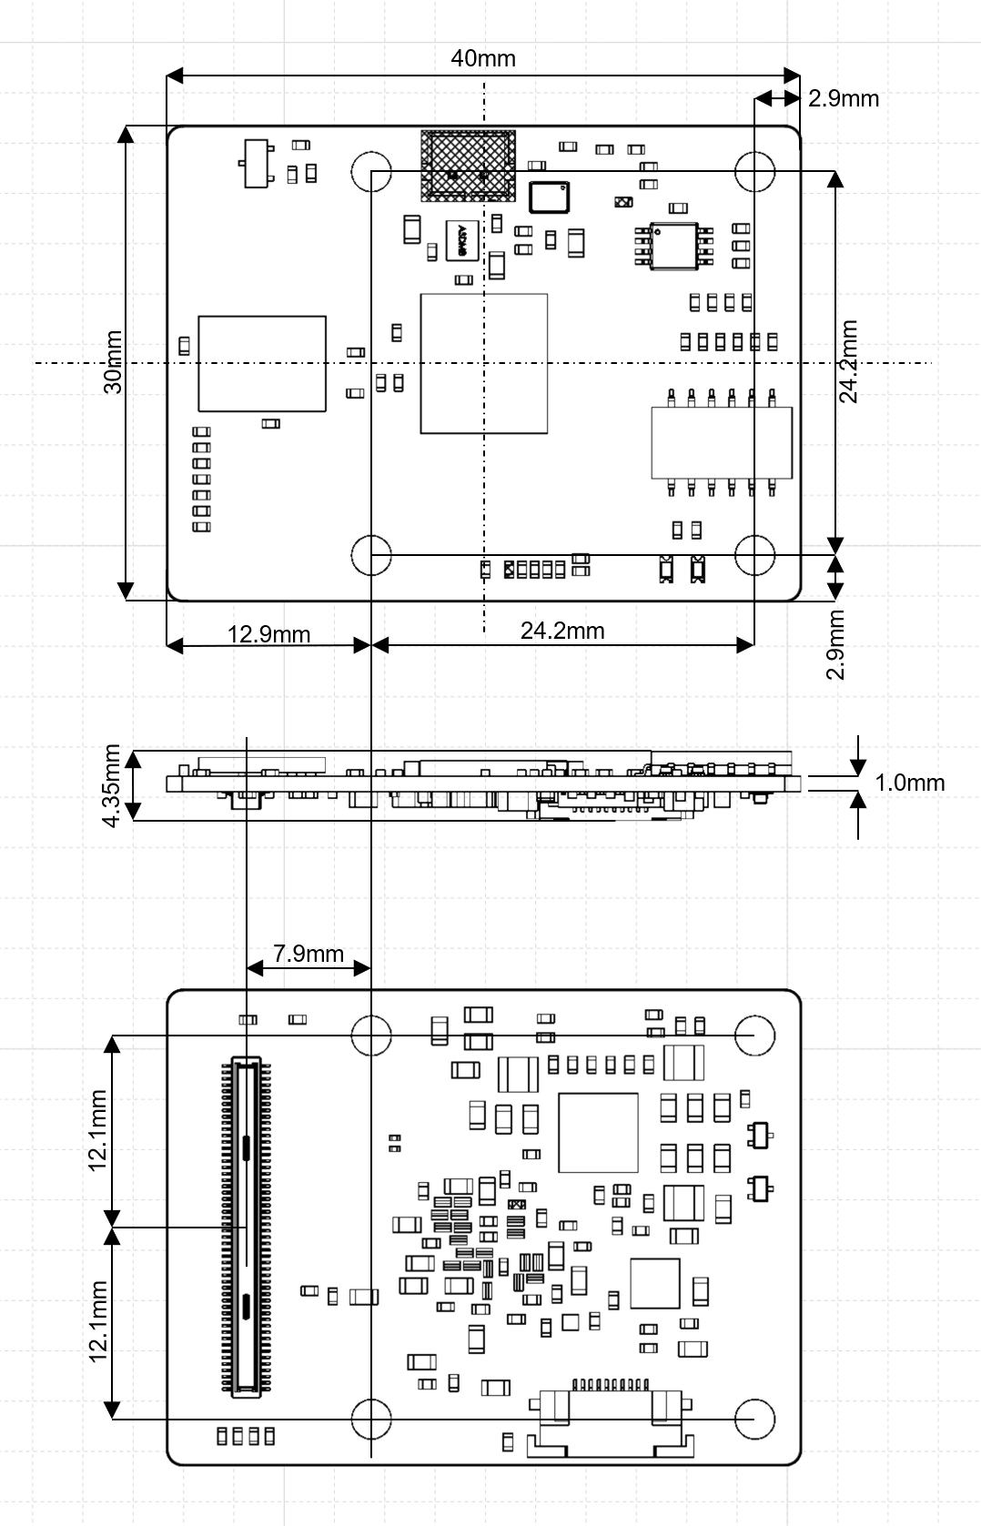

Figure 7 – Top, Side, and Bottom dimensions

## 8.2 Recommended Mounting Configuration

The OAK-SoM-IoT SoM is designed to be used with a 3mm mated-height connector and accompanying 3mm standoffs. The B2B connector plug is on the OAK-SoM-IoT (Hirose DF40C-100DP-0.4V), while the receptacle, which determines mated height, is on the baseboard (Hirose DF40HC(3.0)-100DS-0.4V). Wurth Elektronik 9774030243R SMT standoffs are recommended.

## 8.3 OAK-SoM-IoT Mounting Holes

The OAK-SoM-IoT has 4 M2.5 mounting holes for securing the SoM. These mounting holes use a 2.6mm ID, and a 5.5mm OD pad, which is tied to SoM GND. M2-0.40 screws can be used with these pads to secure the SoM to the recommended Wurth Elektronik 9774030243R SMT standoffs, or a custom solution using M2-0.40 or M2.5-0.45 screws can be used. Note that when using M2.5-0.45 screws, there is reduced tolerance between the B2B connector clocking and the screws’ hole alignment. This must be accounted for to ensure proper connector mating.

## 8.4 SoM Clearance

3mm is the board-to-board standoff height when using the recommended mounting configuration, however, components on the underside of the OAK-SoM-IoT reduce this clearance. For highest design reliability, it is recommended not to place components on the baseboard underneath the SoM, but components with max height <1mm will have clearance.

In previous designs many components have been successfully placed on the baseboard beneath the SoM making careful use of the 3D STEP file of the SoM, which is available upon request.

# 9 Thermal Information

Power consumption can vary considerably depending on the application. A stereo vision application running Mobilenet-SSD V2 at 30fps typically consumes about 2.5W, but more aggressive applications can consume closer to 5W. Most of this power is consumed by the MA2485. While the VFBGA provides an excellent thermal path from the MA2485 to the SoM, the thermal sink is small, and the part temperature can quickly rise toward the 105C max die temperature.

Heatsinking of the MA2485 is required for most applications.

Table 4 details thermal parameters for the MA2485 simulated in a still air environment, an ambient temperature of 25C, 2W power dissipation, and under the test conditions described in JESD51-2A.

|  |  |  |
| --- | --- | --- |
| **Parameter** | **Value (C/W)** | **Description** |
| θJB | 5.8 | Junction-to-board thermal resistance (EIA/JESD51-8) |
| θJC | 3.1 | Junction-to-case thermal resistance |
| θJA | 21.4 | Junction-to-ambient thermal resistance (EIA/JESD51-2) |

Table - MA2485 Thermal Parameters

# 10 Revision History

* Initial Release – November 2020
* Revision 0.1 – March 2021
  + Corrected I2C3 swapped SDA/SCL on pins 78/80 of 100pin connector.
* Revision 0.2 – June 2021
  + Renamed connector GPIO names with one used on MA2485-CO
* Revision 0.3 – July 2021
  + Changed naming convention and added variants
* Revision 0.4 – September 2021
  + Changed naming convention for Myriad X GPIOs
* Revision 0.5 – November 2021
  + Changed names in the Table 3 – Pin name/pin functionality column
  + Added USB 3.1 interface description and table